**Institute of Technology Tralee**

**BSc. in Computing with Specialism (Group 1) - Year 1**

**Continuous Assessment #2**

**Date: 11/12/14**

**Time: 2 – 4 p.m.**

**Introduction to Programming**

**Instructions:** Attempt the following question. You should use the JCreator IDE for coding. When you are finished you must print out your code for correction.

**________________________________________________________**

**Q1.**

A program is required that will read in a user-supplied password and determine whether or not it is valid. For the purposes of this exam we will say that a valid password

* Contains between 8 and 13 characters inclusive
* Must contain at least 2 digits
* Must contain at least 1 uppercase letter
* Must contain at least 3 lowercase letters
* Cannot contain any illegal characters i.e. characters other than digits and letters

Your program should test the user-supplied password against each of the criteria outlined above and, if it fails on any of the criteria listed, then these should be reported by the program. Note that in some cases the password will fail for several reasons and all these reasons should be reported.

Using the test values as indicated in the screen shots below, the program should give you **exactly** the following output when it runs, including any banners, blank lines, tabs etc. Note that the sample runs here do not cover all the possible combinations of outputs from the program, so make sure you test your program thoroughly to ensure it is working in all cases.

Also note that there will be a few marks awarded for having a **single-line comment** and **a meaningful multi-line comment at the top of the program**.

**Sample Screen Shots**

**Run 1 – The password contains only lowercase letters and has only 6 characters**

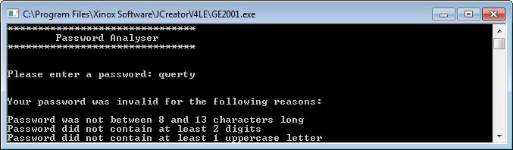

**Run 2 – The password is the right length and has sufficient lowercase and uppercase letters but only contains 1 digit**

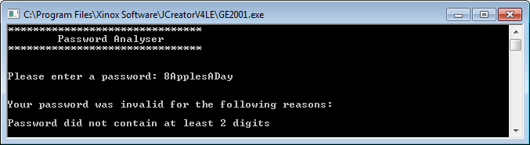

**Run 3 – The password is the right length and has sufficient uppercase letters and digits but contains no lowercase letters and has an illegal character also**

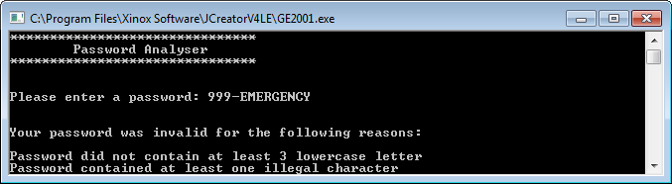

**Run 4 – Although the password contains sufficient numbers of digits, uppercase and lowercase letters and has no illegal characters, it is simply the wrong length**

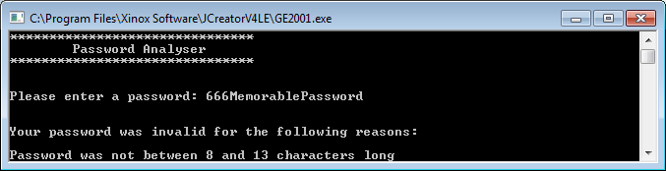

**Run 5 – Everything is wrong with this password ☺**

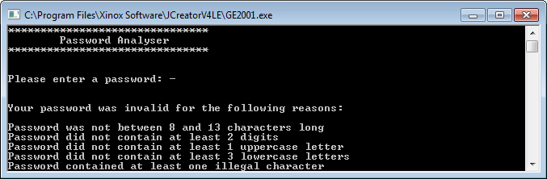

**Run 6 – A perfectly valid password is supplied**

